Week 3 Exercises: Multi-Screen Apps and Navigation
Learning Objectives
After completing this exercise, you should be able to:
• Design a mobile application with multiple screens
• Explain the difference between screens and reusable components
• Use React Navigation in a React Native application
• Navigate between screens using stack navigation
• Pass data between screens using route parameters
• Use local JSON data as application content
• Use React Native Paper components in a multi-screen application
• Recognize common mobile navigation patterns
My Github repository:
https://github.com/mkzaw25101999/Mobile_Development_2_assignment

Part 1: Mobile Navigation
- A screen is a complete view that represents one full page the user navigates to, such as my Home, List and Detail screens and they are registered in the navigator. A reusable component is a smaller building block used inside screens. In this assignment, like my HeroCard, which I reuse for every hero in the list. Screens are whole pages: components are parts used within them.
- Stack navigation manages screens like a stack of cards. When the user moves to a new screen, it is pushed on top of the previous one; when they go back, the top screen is popped off and the one underneath is shown again. Because the previous screen stays in the stack, a back arrow appears automatically.
- Route parameters are pieces of data passed from one screen to another during navigation. In my assignment, when the user taps a hero, I pass that hero as a parameter to the Details screen. They are useful because a single Details screen can show any hero depending on what was passed, instead of building a separate screen for each item.
- Back navigation lets the user return to the previous screen, which matches how people expect mobile apps to behave. It removes the current screen from the stack and shows the one before it, so the user can move around easily without getting stuck.
- Stack navigation layers screens on top of each other, so the user moves forward to a new screen and back to previous one, which is the pattern I used in my assignment application. Bottom tab navigation places a bar of tabs at the bottom of the screen, letting the user switch instantly between a few main sections such as Home, Search, and Profile. Drawer navigation uses a side menu that slides in from the edge with a list of destinations, which suits apps that have many sections to move between.
- Bottom tabs are better when an app has a few equally important sections the user switches between often, since each section is only one tap away. Stack navigation is better for step by step.

Part 2: Create a Multi-Screen Application
Create a React Native application with at least three different screens. Choose your own application topic or extend your previous homework. The application could present information about products, events, movies, books, recipes, places, hobbies or another topic of your choice.
The application must contain at least:
• a main/home screen
• a list or content screen
• a details screen
Plan the navigation between the screens before implementing the application.
A application structure is:
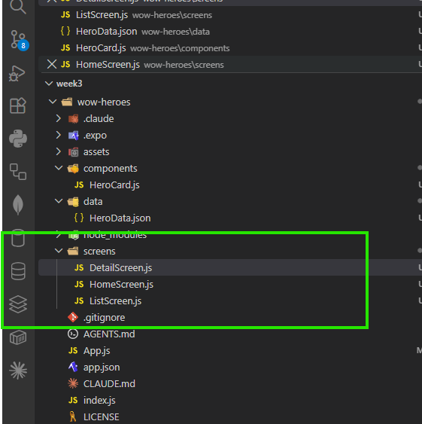

Part 3: React Navigation
Install React Navigation and the required dependencies in your Expo project. Use Native Stack Navigation to implement navigation between your screens.
Your application must demonstrate:
• a navigation container
• at least three screens
• navigating from one screen to another
• back navigation
Organize the screens into separate files.
A project structure is:
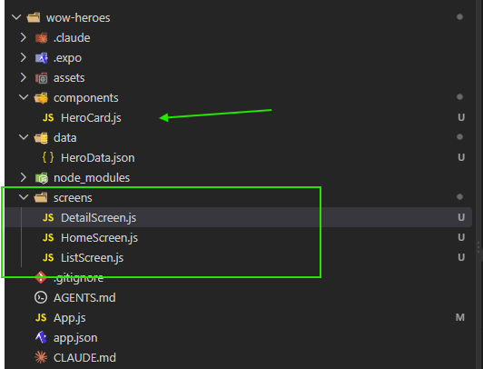
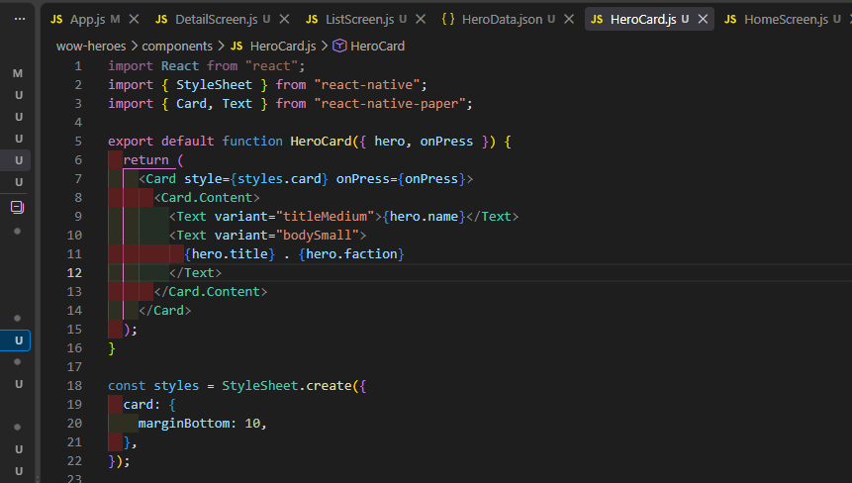
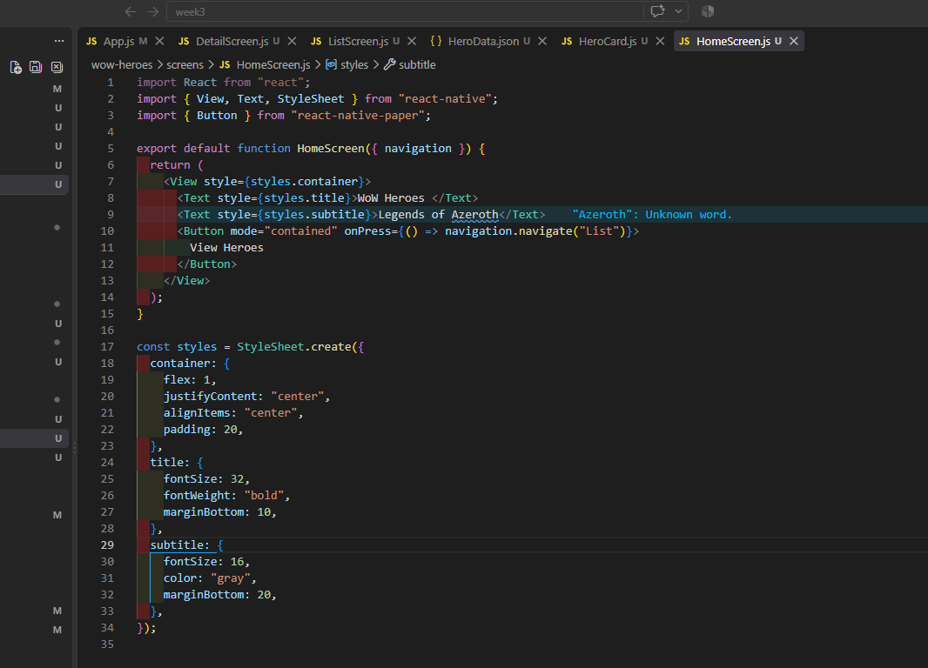
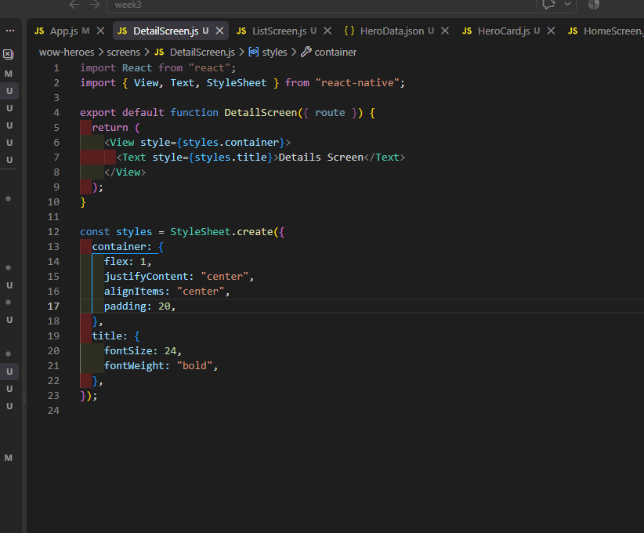

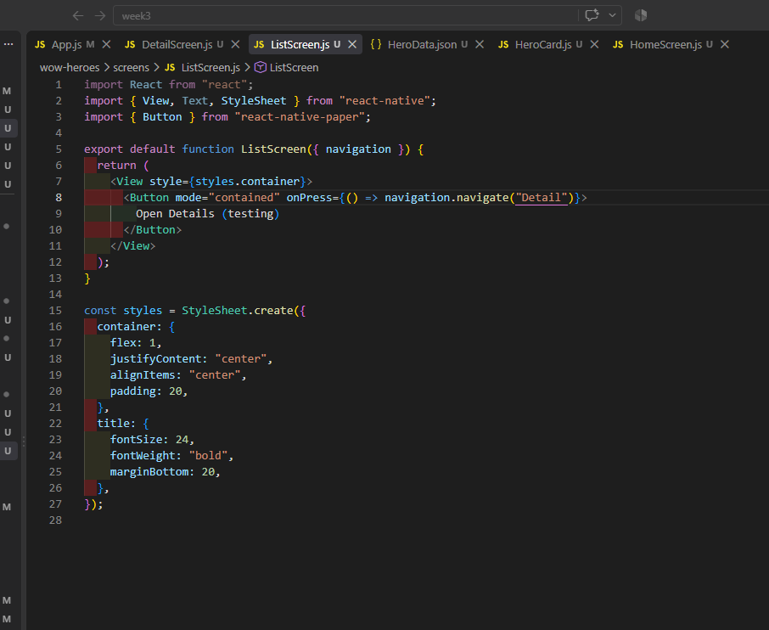
Part 4: Local Data
Create a small local dataset for your application.
Store the data in a separate JSON file:
data/
data.json
The dataset should contain several items and meaningful properties related to your application topic.
Display multiple items from the JSON data on one of your screens.
Use a suitable React Native component such as FlatList to display the data.
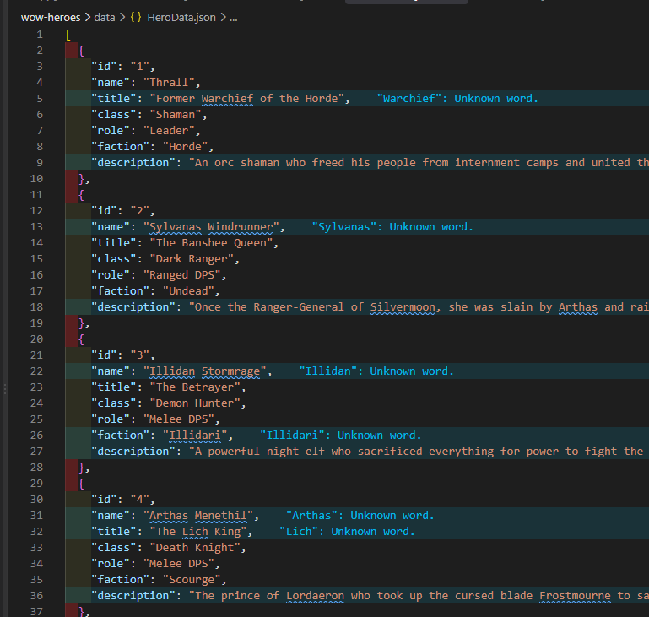
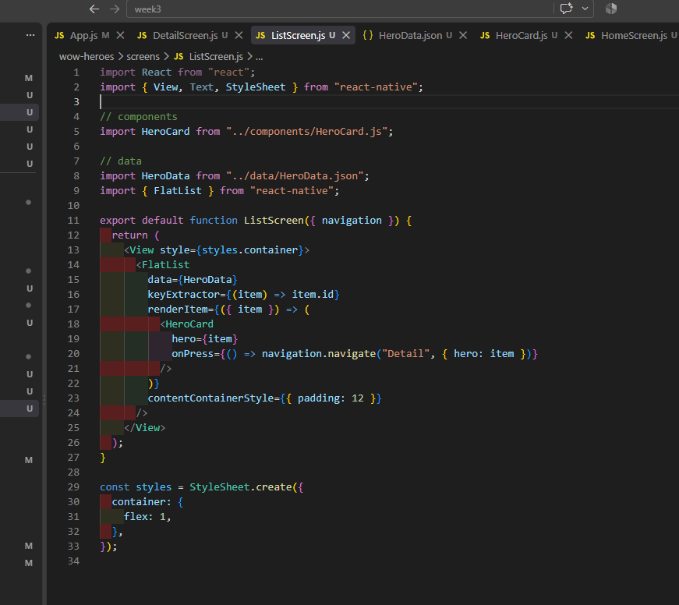

Part 5: Route Parameters and Details Screen
The user must be able to select an item from the list and open its details screen. Pass information about the selected item to the next screen using route parameters. The Details screen must display information about the selected item.
The navigation flow should work approximately like this:
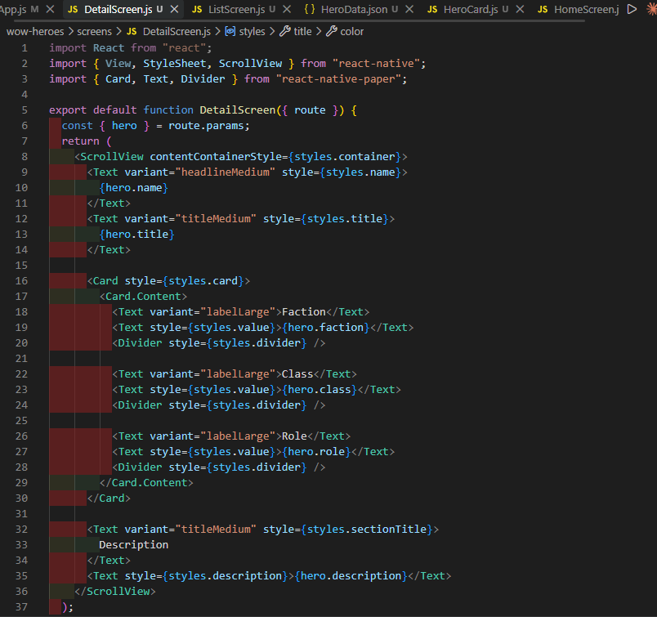
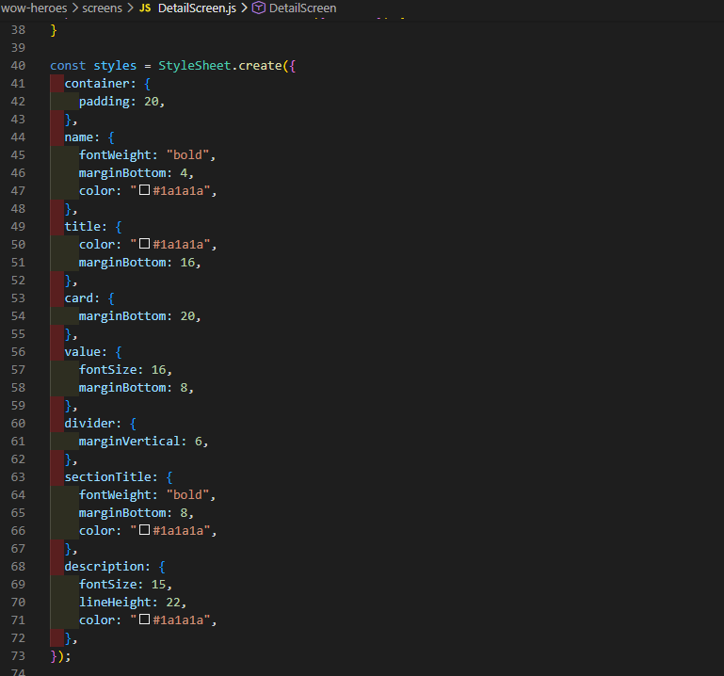
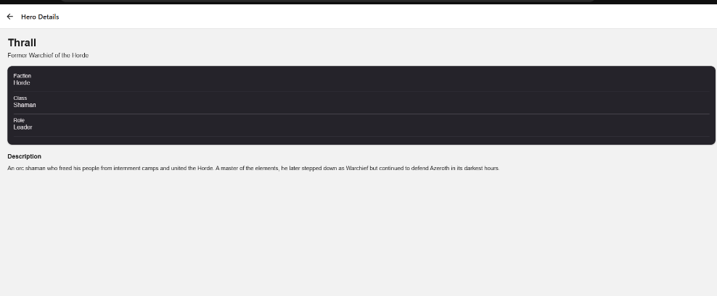
Part 6: UI with React Native Paper
Use React Native Paper to create a consistent user interface.
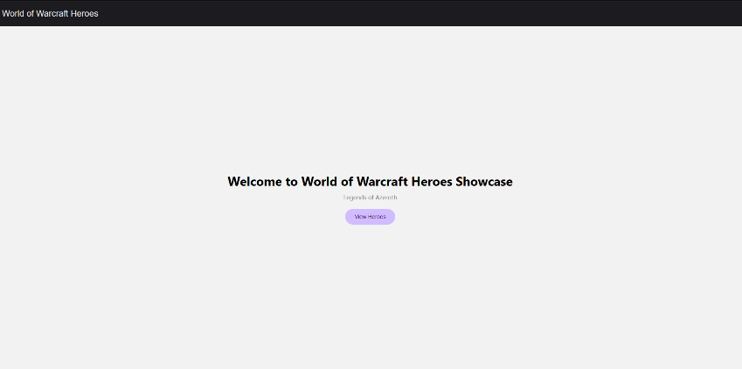
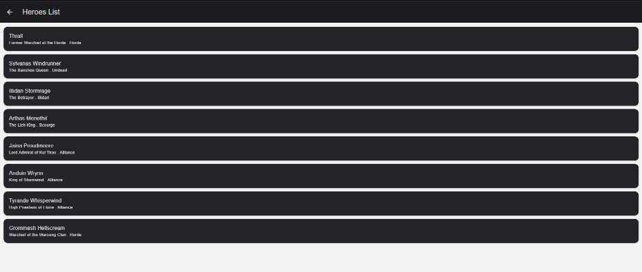
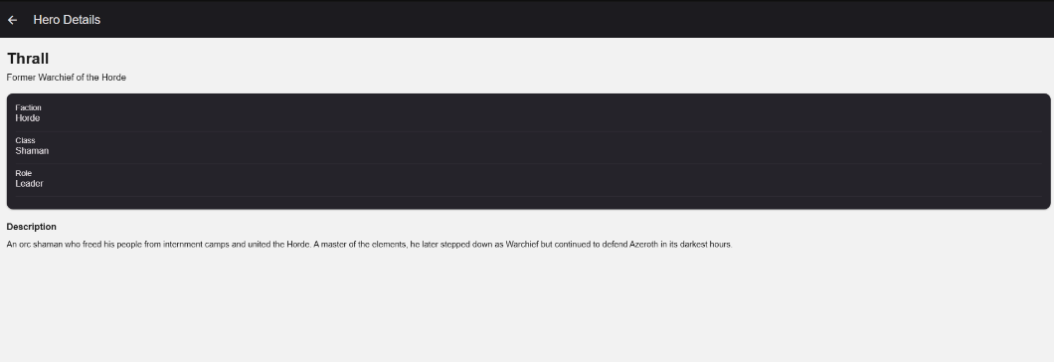
Part 8: Short Reflection
- In my assignment app, screens (Home, List, Details) are the full pages the user navigates between and they are registered in the stack navigation. A component like my HeroCard, is a smaller reusable piece used inside the list screen to display each hero. The screens make up the application’s structure while the component is reused many times within a screen.
- It uses route parameters. When the user taps a hero on the list screen, I pass that hero object to the Details screen. The Details screen then reads it with route.params and displays that hero’s information.
- Because it is more efficient and easier to maintain. I used a FlatList that loops over the JSON data and creates a card for each hero automatically, so I don’t repeat the same code for every item. If I add or change a hero in the data file, the lists updates by itself without touching the layout code.
- React Navigation manages moving between my screes. It provides the navigation container and the native stack navigator that register my three screens, handle navigating from one to another, pass route parameters and give automatic back navigation. It is what turns separate screens into one connected multi-screen app.

